**Competitive Analysis**

**Team JASSHANDS**

Epic Win

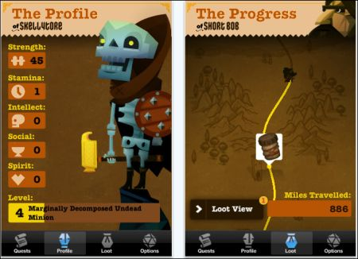

“Epic Win” is a very similar application to our proposed idea. It is primarily a task management app which uses completed tasks as sources of experience points. As more tasks are completed, the player levels up, and progresses through the game.

Key features include quests and loot. Quests are simply the tasks which the user assigns, which can be categorized as 5 different “stats” in-game. The loot are items which can be unlocked after completing some number of quests. Like our idea, loot in “Epic Win” is unlockable as the player levels up.

**Strengths:**

-fun alternative to a typical task management application

-clean, well-made graphics and animations

-syncs with calendar on device

**Weaknesses:**

-lack of multiplayer

-lack of “game” aspect to application (ex. level, stats, and loot do not contribute to any gameplay)

-largely non customizable avatar

HabitRPG

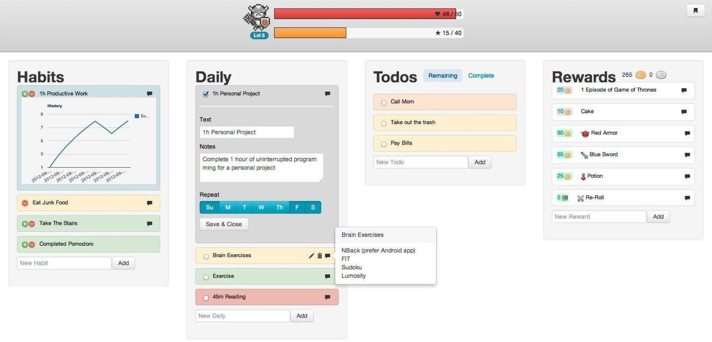

“HabitRPG” provides similar functionality as “Epic Win”, with the key difference of the user determining their own rewards. The interface is very simple and much like a typical task management application, with all tasks written by the user for the user.

The reward system is comprised of two parts: rewards written by the user, and unlockable content to customize the avatar. For example, upon leveling up, a user may unlock new armor or potions. These rewards can be bought using coins earned from completing tasks.

**Strengths:**

-fun alternative to a typical task management application

-customizable avatar

-for repetitive tasks and habits, a progress bar graph is shown

-unlockable clothing

**Weaknesses:**

-lack of multiplayer

-lack of “game” aspect to application (ex. level, stats, and loot do not contribute to any gameplay)

LINE Play

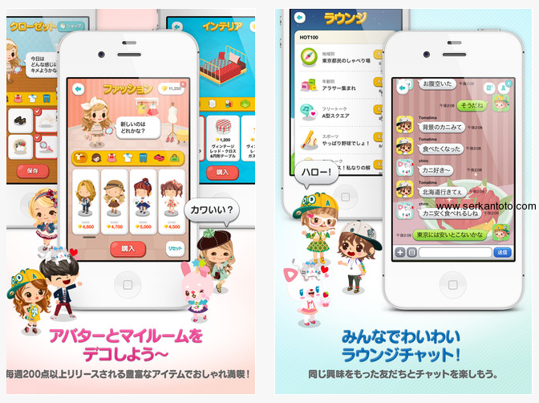

“LINE Play”, a Japanese application based primarily on one’s social network, consists of a community of avatars. Like our proposed product, it features unlockable outfits and a friend system. However, the target audience of “LINE Play” seems to be young, female women, so a greater emphasis is placed on the interface and the variety of unlockable items. In addition, the multiplayer aspect is nothing more than visiting other friends and chatting with them using the LINE calls and messages application.

**Strengths:**

-customizable avatar

-beautiful interface

-friend system

**Weaknesses:**

-lack of gameplay

-very specific audience

-lack of specific goals to complete

Task Hammer

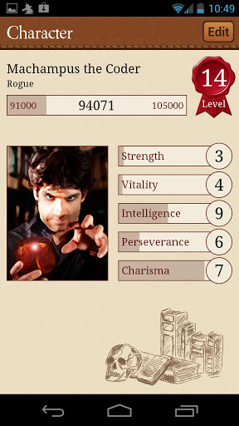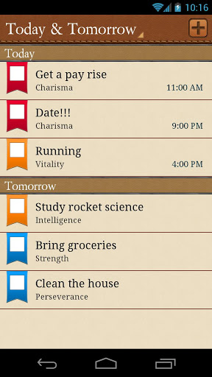

"Task Hammer” is essentially a simplified version of “Epic Win”. It prominently features a task management application with a “game-like” interface built on top. Though the user may improve their skills and level themselves, there is no significance to the skills and level other than for aesthetics. In addition, unlike the other applications as well as our own, there are no “rewards” for the user upon leveling or completing tasks, which may be viewed as a disadvantage for this application.

**Strengths:**

-fun alternative to a typical task management application

-simplified user interface

-good for keeping track of repetitive tasks

**Weaknesses:**

-lack of multiplayer

-lack of reward system

-lack of gameplay elements

Turf Wars

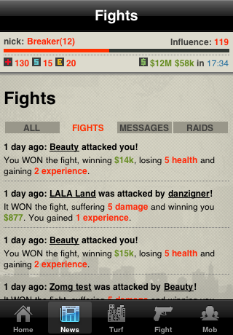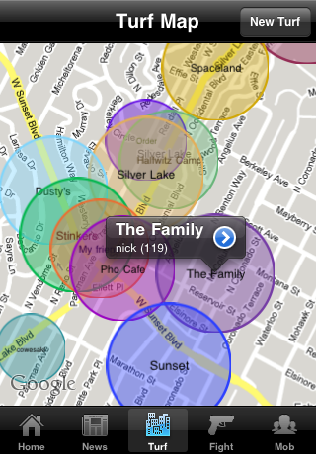

“Turf Wars” employs the use of the built-in geolocation feature of mobile phones. The game itself uses the real world map. In the game, the user plays a mobster whose goal is to expand control of their own territory. In game features include attacking other mobsters, running missions, and increasing their influence and power to further their control. Players can also join forces in order to take down a tough enemy.

**Strengths**:

-strong use of GPS functionality

-interesting and fun gameplay

-PvP functionality

-wide variety of features, such as weapons and upgrades

**Weaknesses:**

-lack of communication between users

-lack of personalization of personal profile

Foursquare

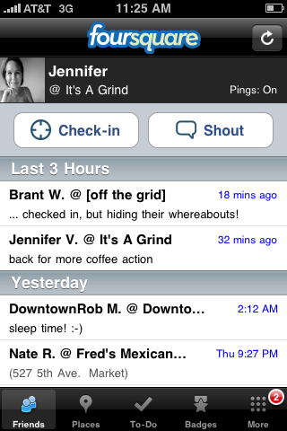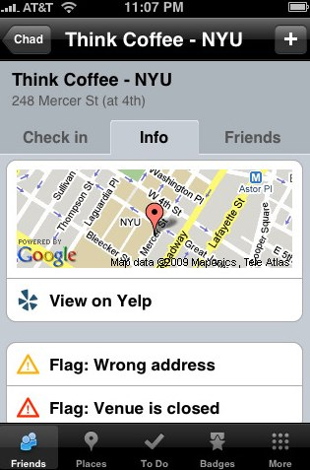

**"**Foursquare" is an application used to check into locations such as shops or landmarks using the GPS functionality and share this experience with other users. Users may leave comments about the check-in as well, which further extends the social experience. In addition, "Foursquare" is "gamified" in that it awards players "badges" for performing some action, such as checking into some location a number of times, or checking into a venue with other users. In addition, if a user visits a venue often enough and becomes the user with the most check-ins at that location, they become the "mayor" of the venue.

**Strengths:**

- strong use of GPS functionality

- socially connects people based on where they have gone

- "badge" and "mayor" systems provide a reward for the user

- clean, easy-to-comprehend interface

**Weaknesses:**

- lack of personalization

Megu

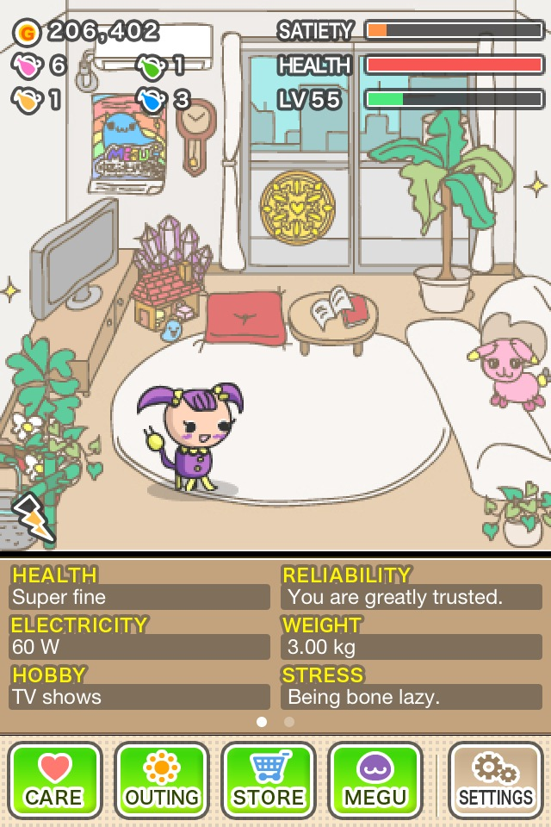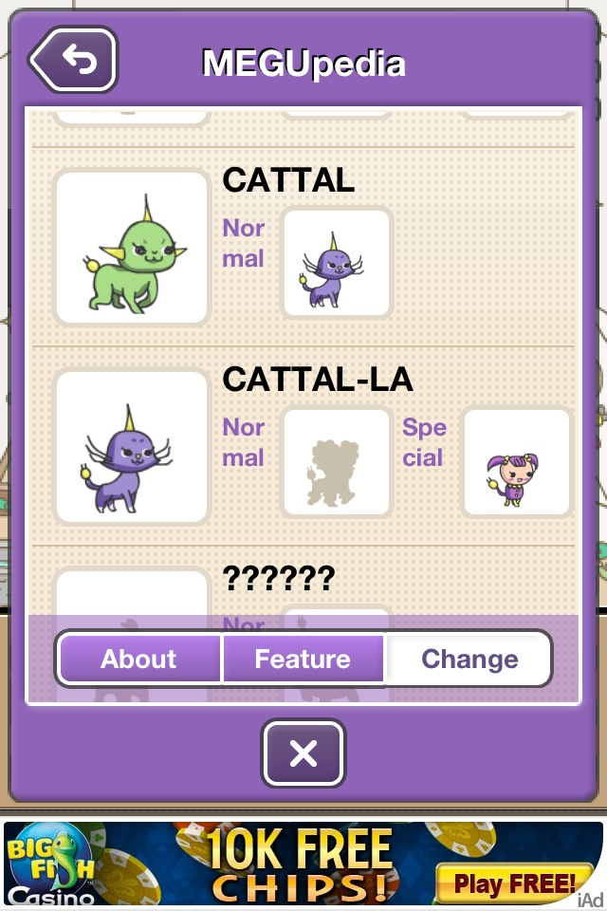

"Megu" is a Tamagotchi-like game in which you are in charge of taking care of a pet, which requires feeding and cleaning and can evolve into other pets. The application targets young women, as the interface stresses a cute atmosphere, typically used to market to the female audience. "Megu" is also similar to Tamagotchi in that a player can interact with another player's pet.

**Strengths:**

- clean, cute interface

- very appealing to young women

- variety of different evolutions as an incentive to play

- customizable furniture

**Weaknesses:**

- lack of activities to perform

- weak social interaction

Any.DO

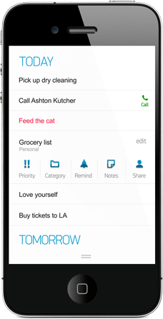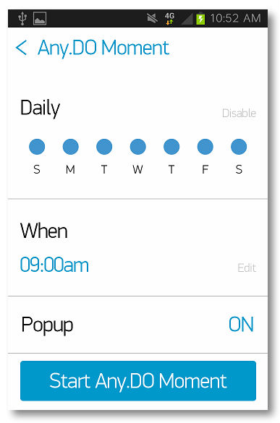

"Any.DO" is a task management application which is purely interested in increasing user productivity. Along with the typical task list, "Any.DO" contains a clean, minimalistic interface, while still providing a great number of features. For example, from the application, a user can sync their schedule with all of their other devices, share their calendar with friends, set reminders, send texts, and call others.

**Strengths:**

- clean, minimalistic interface

- efficient, productivity-contributing features

- wide variety of functionality (ex. texting, calling, setting reminders)

- socially connect people through sharing schedules as well as texting and calling

**Weaknesses:**

- lack of reward system and incentive to complete tasks

**Feature Matrix**

|  |  |  |  |  |  |  |  |  |
| --- | --- | --- | --- | --- | --- | --- | --- | --- |
|  | | Features | | | | | | |
| To-Do List | Rewards | Custom Avatar | Geolocation | Multiplayer | Cross-User Communication | Real World Elements |
| Apps | Epic Win |  |  |  |  |  |  |  |
| HabitRPG |  |  |  |  |  |  |  |
| LINE Play |  |  |  |  |  |  |  |
| Task Hammer |  |  |  |  |  |  |  |
| Turf Wars |  |  |  |  |  |  |  |
| Foursquare |  |  |  |  |  |  |  |
| Megu |  |  |  |  |  |  |  |
| App.DO |  |  |  |  |  |  |  |
|  |  |  |  |  |  |  |  |  |
| Colors denote the following: | | |  |  |  |  |  |  |
|  | feature included | |  |  |  |  |  |  |
|  | feature somewhat included | |  |  |  |  |  |  |
|  | feature not included | |  |  |  |  |  |  |

**Summary**

Of the applications analyzed, the strongest feature among them seems to be the increase in productivity due to the game aspect of typical task management applications. Based on reviews and studies, adding a game feature promotes the application as more fun, which increases a user’s productivity. Since our application is not meant to deter the user from real life, but rather incorporate it, our application will also produce a strong calendar-synced aspect in which the user can record weekly and daily events in addition to a checklist of completed and incomplete tasks.

Some key features which are lacking many applications similar to ours are interactions between users as well as real gameplay. While many applications have a very strong “self-help” component, none attempt to “gamify” the user’s tasks and real life events. In role-playing games, typically the main character is not alone. There are other NPCs or real life players to converse with, for example. Thus, our application will implement these features, and simultaneously tackle the problem of “gamifying” the user experience through the multiplayer aspect. We seek to have nearby players interact in a game or event using the built-in geolocation of mobile devices.

Of the customizable avatar/pet systems, namely LINE Play and Megu, it may be interesting to note that the most enjoyed features are the customizability of a user's in-game room, as well as the decision for what a player's in-game character will look like. For example, the unique avatar system of LINE Play contributes to the user's idea of his or her own identity. Also, Megu allows the user to make decisions, creating a sense of freedom in choosing how the game progresses and how your pet evolves.

Well-designed, popular applications such as Foursquare and Any.DO approach the problem of how to get users to use these applications in different but interesting ways. Foursquare allows users to see where other users are when they check in to venues. In addition, Foursquare initiates a mild form of competition between users, as only one user can be a "mayor" of a venue at a time, which can cause more activity among users. Any.DO spreads its influence in a more subtle way. In addition to its clean interface and clear purpose, Any.DO allows a user to text and call right from the application, which is another way of introducing other users to the application.